Donsun
Contact: sd@donsuntech.com

Pricing
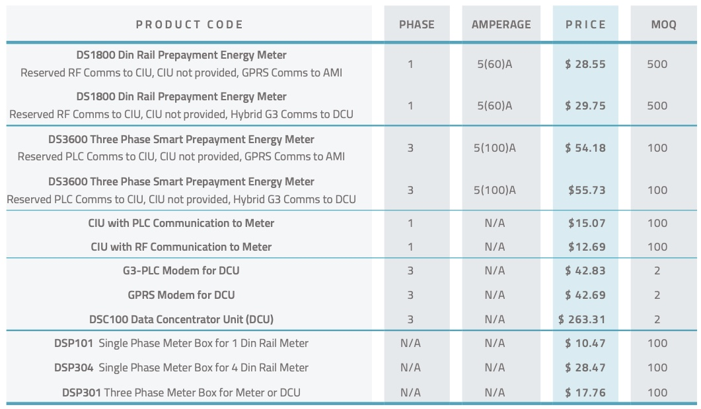

Introduction
Seems like mostly hardware we could build software around

Notes from Tech Comm call

Product Brochure

