Projects
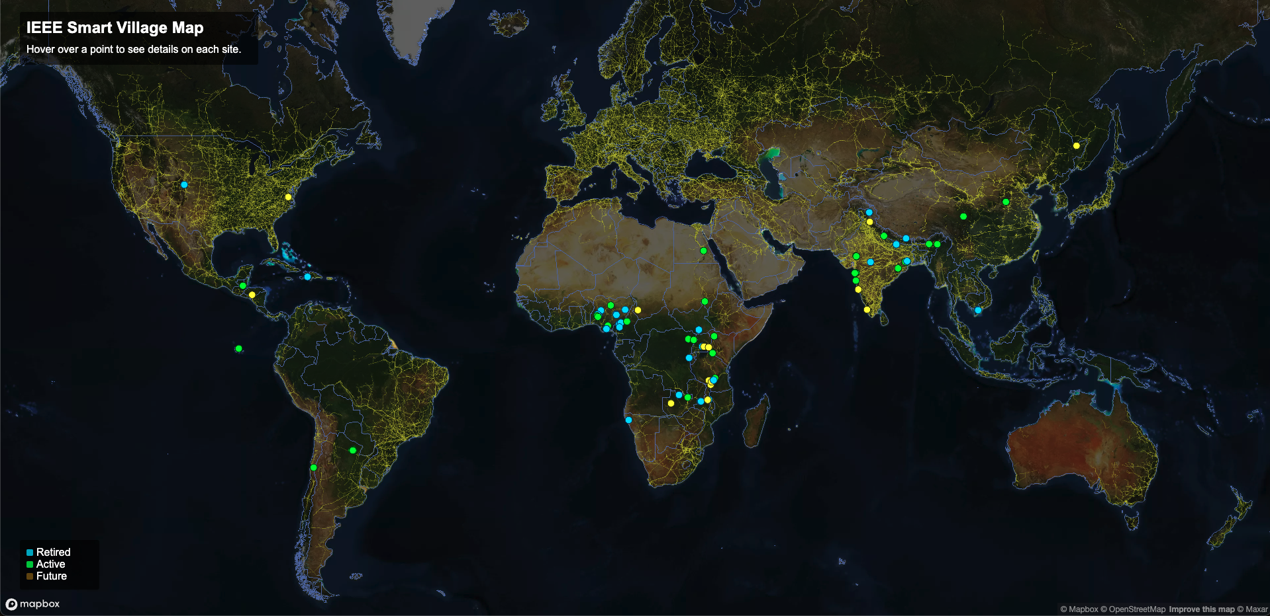
IEEE Smart Village (ISV) has supported a large number of projects that have been deployed around the world, which can be seen on our interactive Projects Map.
See the Projects Template for an outline of how we are thinking about featuring projects. Below is a table listing each project that has received support from ISV, including a link to a project page for documentation for each, followed by our most recent PDF report.

