Initiatives
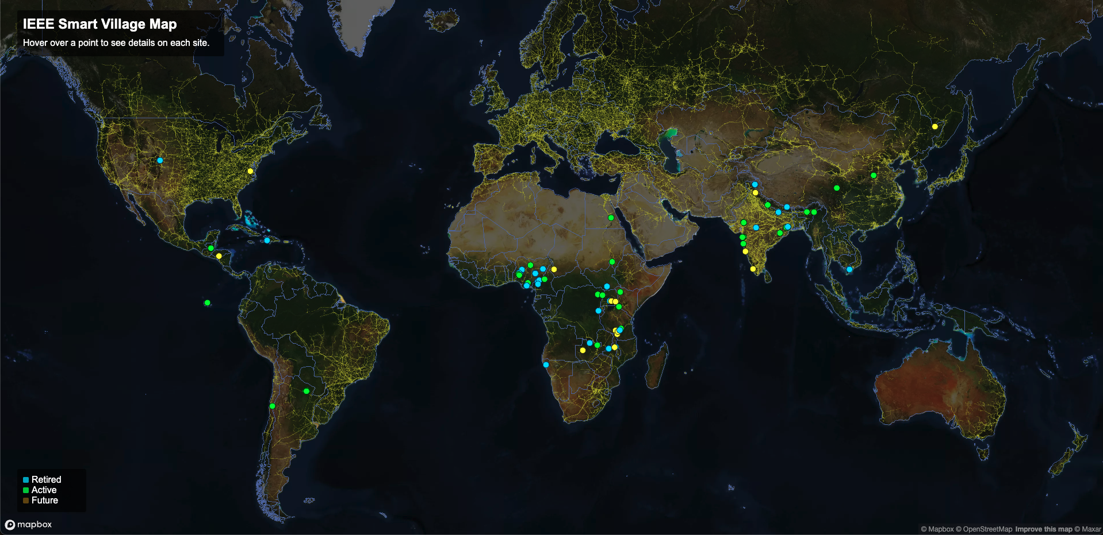
IEEE Smart Village (ISV) has supported a large number of projects that have been deployed around the world, which can be explored on our interactive Projects Map imaged to the right.
Generally, projects receive support ranging from $10,000 to $200,000 USD. These go through the Project Development Committee and their respective Regional Working Groups, and usually include the criteria that a majority of the recipient team needs to be personally based in the area the grant is for, and there needs to be some level of Educational Impact and/or Entrepreneurial Impact associated with the energy system.
See the Projects Template for an outline of how we are thinking about featuring projects. Below is a table listing each project that has received support from ISV, including a link to a project page for documentation for each, followed by our most recent PDF report.
There is an emerging effort to develop our own Software Stack with accomodating Hardware options.
* OpenAMI

