Home
Welcome to the Wiki of IEEE's Smart Village (ISV) Committee. See our official website here: https://smartvillage.ieee.org/. This is a site that is in development using DokuWiki, and growing somewhat organically inspired by other wiki sites, such as the OpenStreetMap Wiki. It is currently hosted by adam.r.sauer@ieee.org, of the ISV Technology Committee, so feel free to register an account, get in contact with him or somebody else on our team, and figure out spots to plug in. Please review syntax and start contributing under IEEEGuidelines, and see the Wiki Playground page for ideas on wiki functionalities. Feel free to create new pages in that :playground header to get started in page editing.

Introduction
ISV is a collection of Electrical Engineers, Entrepreneurs, Community Leaders, and other related individuals working together to facilitate the development, deployment, and continued operation of Renewable Energy systems in disadvantaged communities around the world. For a further breakdown of the organization (mission, vision, history, and structure of the ISV program), see this page created from ISV's Marketing Team: InformationDigest.

Working Groups
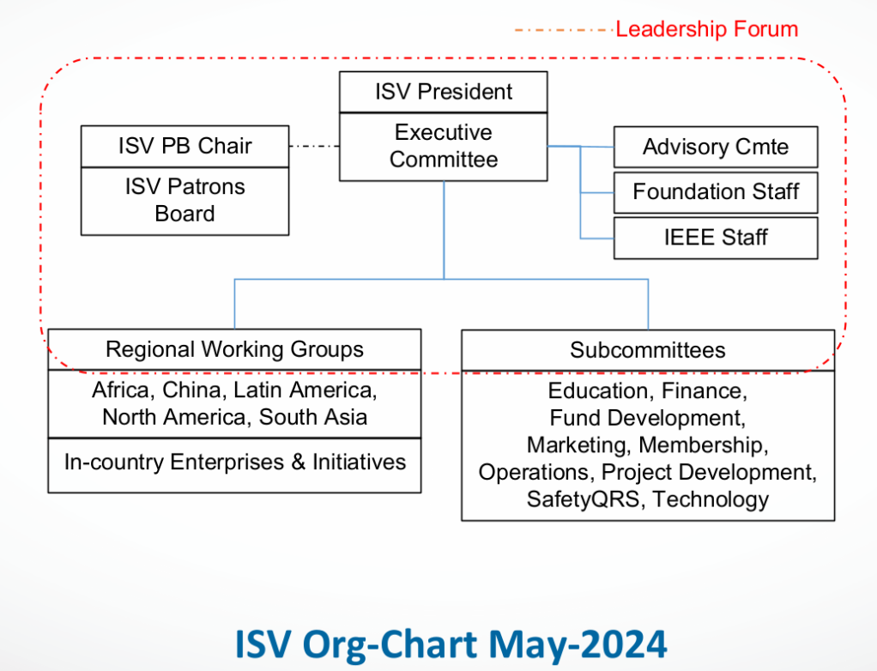
Working Group | Meeting Cadence (Monthly) | Meeting Link | Group Contact
Technology | 2nd & 4th Thursdays |  | Adam Sauer
Project Development |  |  | David Kankam
Marketing |  |  | Oluleke Babayomi
Operations
Safety, Quality, Reliability and Standards | 1st Wednesday |  | Bruno Lequesne
Education |  |  | Toby Cumberbatch
Finance
Membership |  |  | David Sackey

Regional Working Groups
Region | Meeting Cadence | Meeting Link | Group Contact
North America |  |  | Joan Kerr
Latin America |  |  | Mario De La Ossa
Africa |  |  | Abiodun Okunola
China
South Asia |  |  | Sasi Kottayil

Initiatives
ISV has supported over ___ initiatives deployed throughout the world, which can be seen on our interactive Projects Map. See the Projects Template for an outline of how we are thinking about featuring initiatives. For a deeper dive into these initiatives, see our Initiatives wiki page.

Project Development Process
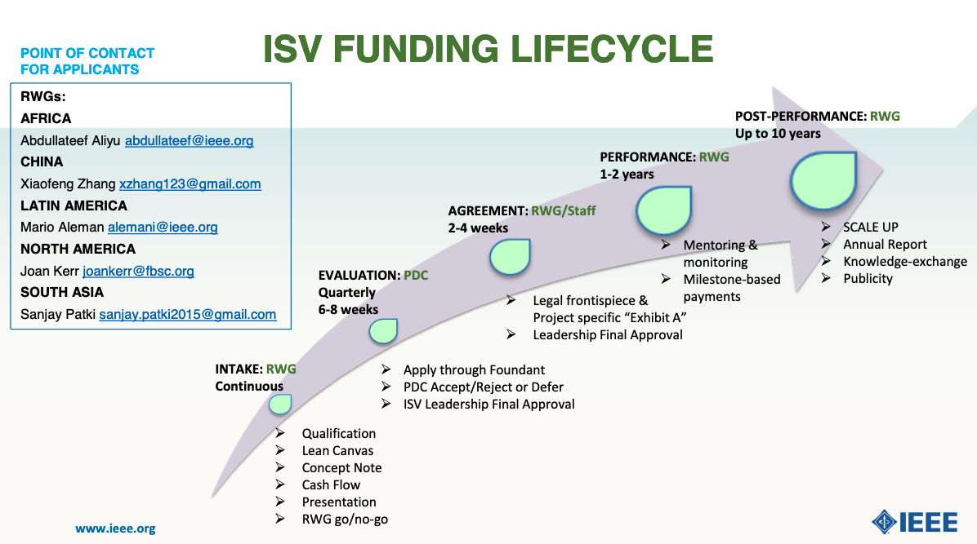
The Regional Working Groups handle most of the projects for their region, and the PDC assists in diving deeper to assist in a subset of those projects.
A thought on the Planning process: Develop resources like this map to better plan projects in areas of need

Technologies
Technologies

Safety, Quality, Reliability and Standards
Safety, Quality, Reliability and Standards

Impact
Impact

Training Resources
How to design a DevelopmentIntervention.
WASH resources from Rural Water Supply Network on D groups

Ways to Support
Donate

